ELDROID
FUNCTIONAL REQUIREMENTS SPECIFICATION
Project Documentation Template

Project Title | SmartDock: IoT-Enabled RFID-Based Equipment Management System with Cloud Tracking and Mobile/Web Monitoring
Team / Group | NullPoint
Team Members | Robie Dana De Paz; Dariel Flores; Bryce Mendez; Han Song Carl Malalay
Section | 4C
Instructor | Mr. Roche A. Plando
Date Submitted | September 2, 2026

Purpose: Define what the proposed ELDROID project must do before implementation begins.

1. Project Overview
Project Title | SmartDock: IoT-Enabled RFID-Based Equipment Management System with Cloud Tracking and Mobile/Web Monitoring
Brief Project Description | SmartDock is an IoT-based equipment management system that automates and monitors the borrowing and returning of shared school equipment. It combines RFID borrower authentication, continuously monitored open storage boxes, an ESP32 controller, item-presence sensors, Firebase cloud services, and mobile/web monitoring to track equipment availability, borrower activity, transaction history, due dates, and security alerts in real time.
Problem Being Addressed | Manual paper-based checkout, verbal hand-offs, untracked returns, slow equipment status checking, and the risk of unauthorized removal or walk-off loss in shared school equipment rooms.
Target Users | Registered borrowers and authorized administrators/staff.
Proposed Environment / Context | Prototype-scale school equipment environments such as an AV room, library equipment counter, or department storage cabinet using a stacked, open docking tower with one designated item per monitored box.

2. Project Objectives

2.1 General Objective
To design and develop SmartDock as an IoT-enabled equipment borrowing and return system that uses RFID authentication, continuous item-presence sensing, and cloud-based monitoring to provide secure, automated, and real-time equipment management.

2.2 Specific Objectives
1. To authenticate registered borrowers through RFID identification cards and open time-limited borrowing or return sessions.
2. To continuously detect the presence or removal of assigned equipment in each open storage box and distinguish authorized from unauthorized removal events.
3. To record borrowing, return, due-time, overdue, and security-event data in the cloud and synchronize equipment status in real time.
4. To provide borrower mobile monitoring and an administrator web dashboard for availability, due dates, alerts, borrower information, and borrowing history.

3. Scope and Limitations

3.1 Scope
SmartDock includes a prototype docking tower of stacked, doorless equipment boxes; ESP32 microcontroller; MFRC522 RFID reader; registered borrower RFID cards; one IR break-beam or optical photointerrupter item-presence sensor per box; MCP23017 I2C GPIO expander; green/red status LEDs; active buzzer; Wi-Fi connectivity; Firebase cloud backend; borrower mobile application; and administrator web dashboard.
The system covers RFID-based borrower authentication, time-boxed borrow/return sessions, first-removal item selection, sensor-based return detection, automatic status updates, due-time and overdue notifications, unauthorized-removal alarms, transaction logging, and real-time monitoring. The intended context is a school AV room, library equipment counter, or department storage area where small shared equipment such as microphones, HDMI cables, presentation remotes, chargers, and adapters are assigned to individual monitored boxes.

3.2 Limitations
The prototype does not include GPS asset tracking, computer-vision item recognition, biometric authentication, physical locks or latches on individual boxes, automated billing or fines processing, or integration with third-party inventory or payroll systems.
Security detects and alarms unauthorized removal rather than physically preventing access because the storage boxes remain open. Correct operation also depends on power, Wi-Fi/cloud availability for synchronization, proper RFID registration, and reliable sensor alignment.
Each box is designed for one assigned item, and item identity is inferred from the monitored box rather than from an RFID tag attached to the equipment itself.

4. User Roles / Actors
Actor / User Role | Description | Main Interactions
Borrower | Registered user issued an RFID identification card and access to the borrower mobile application. | Tap RFID card; borrow/return equipment; view availability and own borrow/due status; receive reminders and overdue notifications.
Administrator / Staff | Authorized personnel responsible for monitoring SmartDock operations through the web dashboard. | View all equipment and borrower status; monitor alerts; review borrowing history; manage users/items/boxes and respond to overdue or unauthorized events.

5. Functional Requirements
ID | Function / Feature | Requirement Statement | Priority
FR-01 | RFID Authentication | The system shall allow a registered borrower to tap their RFID identification card at the docking tower reader to open a time-boxed borrow or return session. | High
FR-02 | Item-Presence Monitoring | The system shall continuously monitor each assigned equipment box using its dedicated item-presence sensor. | High
FR-03 | Authorized Borrow Detection | The system shall identify the first item removed during an active RFID session, bind that box/equipment ID to the borrower, and record the borrow event with borrower ID, equipment ID, borrow time, and due time. | High
FR-04 | Unauthorized Removal Alert | The system shall trigger the buzzer and red indicator, send a real-time administrator alert, and log an unauthorized event when an item is removed without a valid active session. | High
FR-05 | Borrow Confirmation | The system shall display the borrowed item name, borrow time, required return time, and box location in the borrower mobile application after a successful borrow. | Medium
FR-06 | Due and Overdue Notifications | The system shall send a reminder as the due time approaches and an overdue notification when the due time passes without a return. | High
FR-07 | Overdue Escalation | The system shall alert the administrator dashboard and flag the borrower account when an item remains overdue beyond the defined grace period. | High
FR-08 | Return Processing | The system shall require the borrower to tap their RFID card to open a return session and shall attribute the next matching item-placement event to that borrower. | High
FR-09 | Automatic Availability Update | The system shall automatically update an item status to Available when its box sensor detects that the item has been returned during a valid return session. | High
FR-10 | Real-Time Monitoring and History | The system shall display item availability and the borrower's own borrow/due status on mobile, and shall display all box statuses, borrower information, alerts, and complete borrowing history on the administrator web dashboard. | High
FR-11 | Automatic Reconnection | The system shall automatically handle Wi-Fi and I2C-bus reconnection to maintain sensor monitoring and event logging after a temporary connection interruption. | Medium

6. Non-Functional Requirements
ID | Category | Requirement Statement | How It Will Be Verified
NFR-01 | Performance | The system shall propagate borrow, return, status, and alarm updates to connected mobile/web clients with low latency suitable for real-time monitoring. | Perform borrow/return/alarm tests and confirm that connected clients receive the updated state promptly.
NFR-02 | Security | The system shall use Firebase Authentication, Firebase Security Rules, and HTTPS/TLS to restrict access and protect transmitted data. | Attempt authenticated/unauthenticated access and inspect security rules and encrypted network requests.
NFR-03 | Reliability | The ESP32 firmware shall recover from temporary Wi-Fi or I2C interruptions without requiring a full system restart. | Interrupt Wi-Fi/I2C connectivity, restore it, and verify reconnection and resumed monitoring.
NFR-04 | Usability | The system shall provide clear RFID tap feedback, borrow/return status, due information, and visible alarm indications through the applications and tower indicators. | Conduct task-based user testing for tap, borrow, return, status viewing, and alert recognition.
NFR-05 | Connectivity | The IoT controller shall use 2.4 GHz Wi-Fi and HTTPS/REST API or WebSocket communication for cloud synchronization, with SPI for the RFID reader and I2C for sensor expansion. | Verify network and hardware interfaces during integration testing.
NFR-06 | Compatibility | The system shall operate with the ESP32, MFRC522 reader, MCP23017 expander, 13.56 MHz MIFARE borrower cards, and digital IR break-beam/photointerrupter sensors specified for the prototype. | Test each specified component with the integrated prototype.
NFR-07 | Data Integrity | The system shall reject malformed payloads, duplicate taps, and unrecognized RFID UIDs before they can alter equipment status. | Submit invalid, duplicate, and unregistered inputs and verify that stored equipment status remains unchanged.

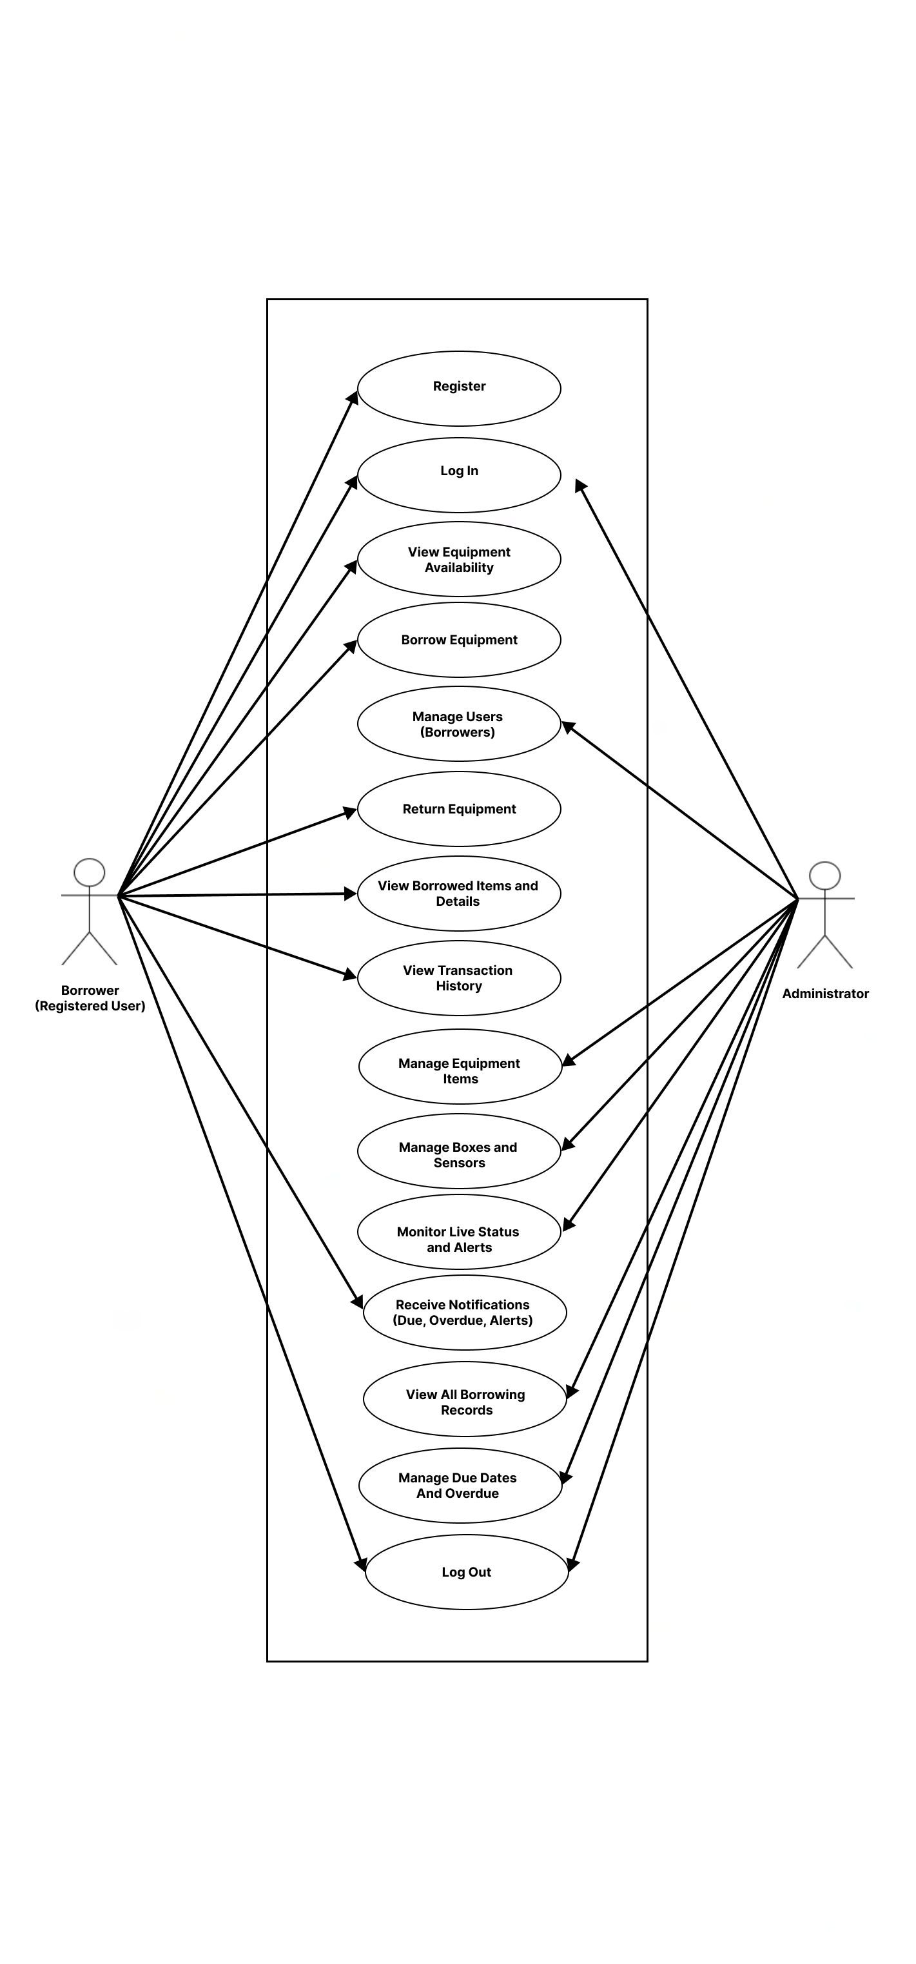
7. Use Case Diagram

Figure 1. Use Case Diagram
8. System Architecture Diagram
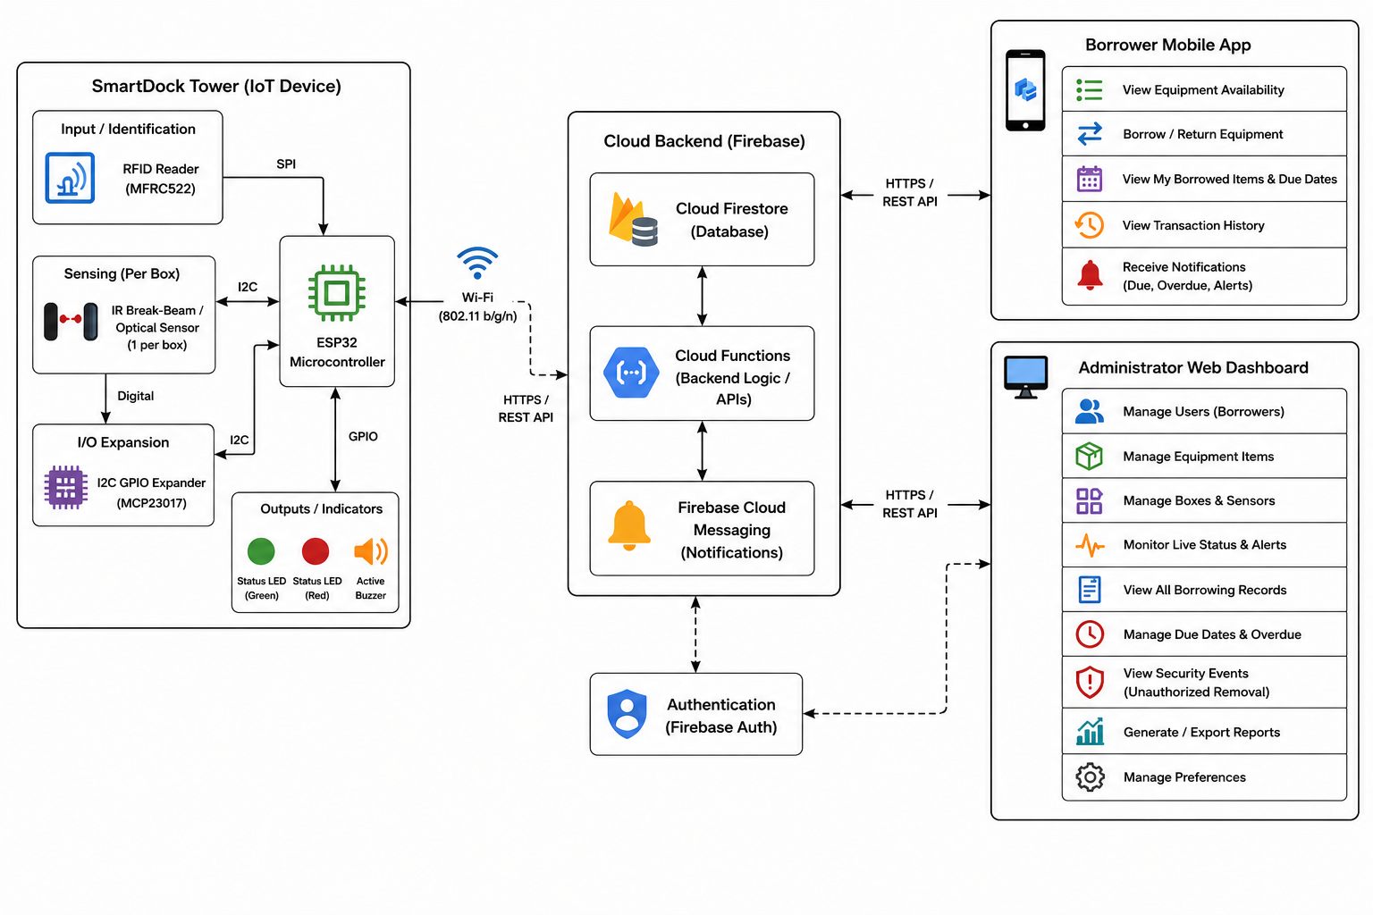
Figure 2. System Architecture Diagram

8.3 Architecture Description
A borrower taps a registered 13.56 MHz RFID card on the MFRC522 reader. The reader sends the UID to the ESP32 through SPI, and the ESP32 opens a short authenticated borrow or return session when the card is valid. Each open equipment box has an IR break-beam or optical photointerrupter sensor. Sensor signals are read through the MCP23017 I2C GPIO expander, allowing the ESP32 to detect item removal or placement and determine whether the event occurred inside a valid session.
The ESP32 provides local feedback through green/red LEDs and an active buzzer, then synchronizes validated borrow, return, and alarm events to Google Firebase over 2.4 GHz Wi-Fi using HTTPS/REST API or a WebSocket stream. Firebase Authentication and Security Rules control access, Firestore stores system data, and Cloud Functions support scheduled due-date checks. The borrower mobile app receives personal availability, borrow, due, and notification data, while the administrator web dashboard receives system-wide status, borrower information, alerts, and history.

9. Technology Requirements
Category | Proposed Technology | Purpose / Justification
Mobile & Web Platform / Framework | Android Native SDK (Mobile App); React.js (Web Administrator Dashboard) | Provides borrower mobile monitoring via native Android app and real-time administrator web monitoring via React.js connected directly to Firebase.
Programming Language | C/C++ (ESP32 Firmware), Kotlin (Android Mobile App), JavaScript / TypeScript (Web Dashboard & Firebase Cloud Functions) | C/C++ enables fast micro-controller hardware operation; Kotlin powers modern native Android development; JavaScript/TypeScript handles the Web Dashboard and cloud logic.
Cloud / Backend | Google Firebase | Provides Authentication, Firestore synchronization, Security Rules, and Cloud Functions for due-date processing.
Database | Google Firebase Firestore | Stores equipment status, active sessions, transactions, alerts, borrower links, and history with real-time listeners.
Microcontroller | ESP32 Development Board | Reads RFID, polls sensors through the I2C expander, controls indicators, and syncs events over Wi-Fi.
Sensors | IR Break-Beam / Optical Photointerrupter | Continuously detects whether the assigned item is present or removed from each open box.
Actuators | 5 mm Green/Red LEDs + Active Buzzer | Provides local confirmation and alarm feedback.
API / External Service | Firebase SDK / HTTPS REST API; WebSocket optional | Connects the ESP32 and client applications to Firebase for synchronized event and status data.
Communication Protocol | Wi-Fi 802.11 b/g/n; SPI; I2C; HTTPS/REST or WebSocket | Wi-Fi/cloud data transfer, SPI for MFRC522, and I2C for MCP23017 sensor expansion.

10. Hardware and Software Requirements

10.1 Hardware Requirements
Item | Specification / Model | Quantity | Purpose
ESP32 Development Board | 3.3V logic, 5V USB input, integrated 2.4 GHz Wi-Fi, SPI/I2C/GPIO | 1 | Main IoT controller and cloud-connected event processor.
MFRC522 RFID Reader | 13.56 MHz ISO/IEC 14443A, SPI, 3.3V | 1 | Reads registered borrower RFID card UIDs.
Borrower RFID Cards | 13.56 MHz MIFARE Classic 1K | As needed | Identifies registered borrowers during tap-in.
Item-Presence Sensors | IR break-beam / photointerrupter, digital output, ~3-5V | 1 per box | Detects assigned item removal and placement.
MCP23017 GPIO Expander | 16-bit I2C GPIO, 3.3V/5V logic | 1 or more | Expands sensor inputs for multiple boxes.
Status LEDs + Active Buzzer | Green/red 5 mm LEDs with 220-330 ohm resistors; 5V active buzzer | 1 set | Provides tap confirmation and unauthorized-removal alarm feedback.
Docking Tower + Power Supply | Stacked acrylic/MDF open boxes; 5V DC 1-2A supply | 1 | Houses one assigned item per box and powers the prototype electronics.

10.2 Software Requirements
Software / Tool | Version  (if applicable) | Purpose
Arduino IDE / ESP32 Toolchain | Applicable current version | Develops and uploads ESP32 firmware for RFID, sensors, connectivity, and event logic.
Google Firebase | Cloud service | Provides Firestore, Authentication, Security Rules, Cloud Functions, and real-time synchronization.
Android Studio | Applicable current version | Development environment for the borrower Android mobile application.
Web Browser | Current version | Accesses the administrator web dashboard.
Firebase Console | Cloud service | Configures Firestore data, Authentication, Security Rules, and Cloud Functions.
Version Control Repository | Applicable current version | Maintains source code and project revisions during development.

11. Requirements Traceability Summary
Objective | Related Requirement ID(s) | Expected Output / Evidence
Objective 1 - RFID authentication and timed sessions | FR-01, FR-08 | Valid RFID tap opens a borrow/return session and return events are attributed to the borrower.
Objective 2 - Continuous sensing and security detection | FR-02, FR-03, FR-04 | Sensor changes identify authorized borrowing and trigger alarms for unauthorized removal.
Objective 3 - Cloud logging, due tracking, and status synchronization | FR-06, FR-07, FR-09, FR-11 | Due/overdue notifications, escalation, automatic availability updates, and connection recovery are demonstrated.
Objective 4 - Borrower and administrator monitoring | FR-05, FR-10 | Borrower mobile screens and administrator web dashboard show the required real-time information.
Overall automated borrow/return workflow | FR-01 to FR-11 | End-to-end prototype test demonstrates tap, remove, log, notify, return, update, and alert behavior.

12. Team Confirmation
By submitting this document, the team confirms that the requirements and architecture described above represent the planned system at the time of submission. Any major change during development should be documented and approved according to the instructor's project guidelines.
Name | Role | Signature / Date
Robie Dana De Paz | Mobile App Developer
Dariel Flores | Cloud & Backend Lead
Bryce Mendez | Mobile App Developer
Han Song Carl Malalay | IoT / Hardware Lead

Instructor Evaluation (For Instructor Use)
Criterion | Points | Score
Completeness and clarity of project requirements | 20
Quality and testability of functional requirements | 25
Appropriateness of non-functional requirements | 10
Use Case Diagram consistency | 15
System Architecture Diagram accuracy and completeness | 20
Technology / hardware / software requirements | 10
TOTAL | 100

